**1.Download the dataset: Dataset**

**2.Load the dataset**

In [5]:

**import** numpy **as** np

**import** pandas **as** pd

df **=** pd**.**read_csv("Churn_Modelling.csv")

**3.Perform Below Visualizations.**

**Univariate Analysis**

In [6]:

**import** seaborn **as** sns

sns**.**histplot(df**.**CreditScore,kde**=True**)

Out[6]:

<matplotlib.axes._subplots.AxesSubplot at 0x7fb65973a3d0>

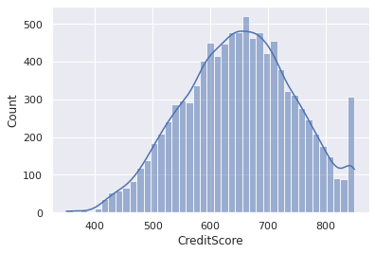

# Bi - Variate Analysis

In [7]:

**import** seaborn **as** sns

**import** matplotlib.pyplot **as** plt

sns**.**scatterplot(df**.**CreditScore,df**.**EstimatedSalary)

plt**.**ylim(0,15000)

/usr/local/lib/python3.7/dist-packages/seaborn/_decorators.py:43: FutureWarning: Pass the following variables as keyword args: x, y. From version 0.12, the only valid positional argument will be `data`, and passing other arguments without an explicit keyword will result in an error or misinterpretation.

FutureWarning

Out[7]:

(0.0, 15000.0)

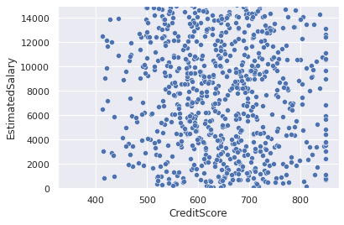

# Multi - Variate Analysis

In [8]:

**import** seaborn **as** sns

df**=**pd**.**read_csv("Churn_Modelling.csv")

sns**.**pairplot(df)

Out[8]:

<seaborn.axisgrid.PairGrid at 0x7fb6430f1590>

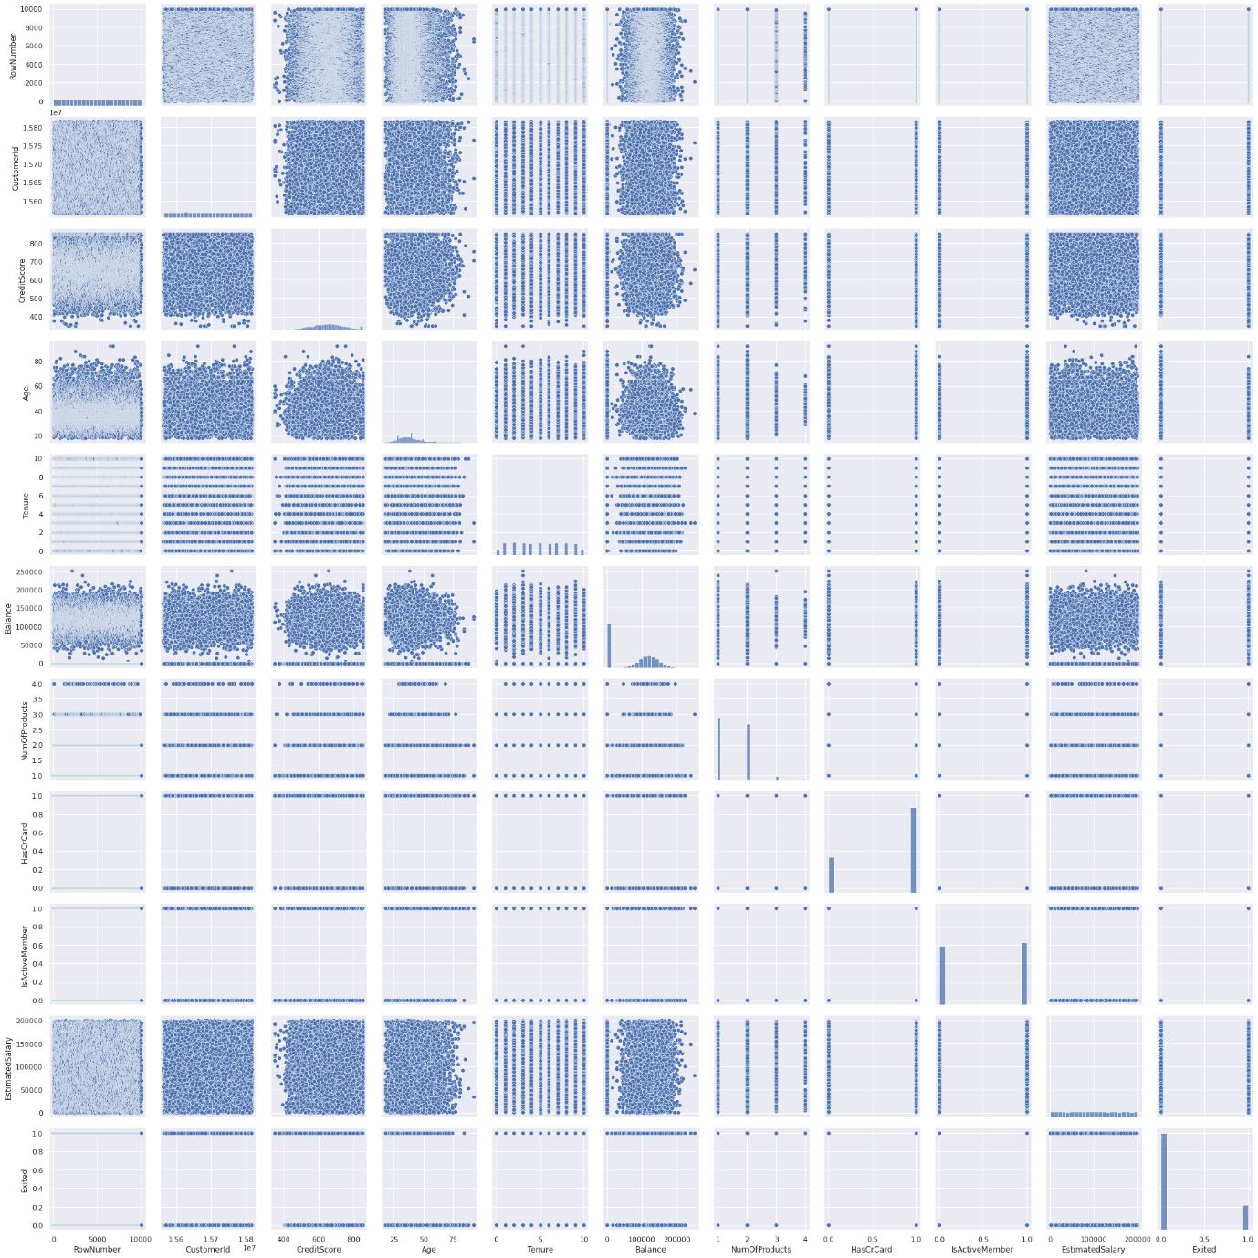

# 4.Perform descriptive statistics on the dataset.

In [9]:

df**=**pd**.**read_csv("Churn_Modelling.csv")

df**.**describe(include**=**'all')

Out[9]:

|  | **RowNumber** | **CustomerId** | **Surname** | **CreditScore** | **Geography** | **Gender** | **Age** | **Tenure** | **Balance** | **NumOfProducts** | **HasCrCard** | **IsActiveMember** | **EstimatedSalary** | **Exited** |
| --- | --- | --- | --- | --- | --- | --- | --- | --- | --- | --- | --- | --- | --- | --- |
| **count** | 10000.00000 | 1.000000e+04 | 10000 | 10000.000000 | 10000 | 10000 | 10000.000000 | 10000.000000 | 10000.000000 | 10000.000000 | 10000.00000 | 10000.000000 | 10000.000000 | 10000.000000 |
| **unique** | NaN | NaN | 2932 | NaN | 3 | 2 | NaN | NaN | NaN | NaN | NaN | NaN | NaN | NaN |
| **top** | NaN | NaN | Smith | NaN | France | Male | NaN | NaN | NaN | NaN | NaN | NaN | NaN | NaN |
| **freq** | NaN | NaN | 32 | NaN | 5014 | 5457 | NaN | NaN | NaN | NaN | NaN | NaN | NaN | NaN |
| **mean** | 5000.50000 | 1.569094e+07 | NaN | 650.528800 | NaN | NaN | 38.921800 | 5.012800 | 76485.889288 | 1.530200 | 0.70550 | 0.515100 | 100090.239881 | 0.203700 |
| **std** | 2886.89568 | 7.193619e+04 | NaN | 96.653299 | NaN | NaN | 10.487806 | 2.892174 | 62397.405202 | 0.581654 | 0.45584 | 0.499797 | 57510.492818 | 0.402769 |
| **min** | 1.00000 | 1.556570e+07 | NaN | 350.000000 | NaN | NaN | 18.000000 | 0.000000 | 0.000000 | 1.000000 | 0.00000 | 0.000000 | 11.580000 | 0.000000 |
| **25%** | 2500.75000 | 1.562853e+07 | NaN | 584.000000 | NaN | NaN | 32.000000 | 3.000000 | 0.000000 | 1.000000 | 0.00000 | 0.000000 | 51002.110000 | 0.000000 |
| **50%** | 5000.50000 | 1.569074e+07 | NaN | 652.000000 | NaN | NaN | 37.000000 | 5.000000 | 97198.540000 | 1.000000 | 1.00000 | 1.000000 | 100193.915000 | 0.000000 |
| **75%** | 7500.25000 | 1.575323e+07 | NaN | 718.000000 | NaN | NaN | 44.000000 | 7.000000 | 127644.240000 | 2.000000 | 1.00000 | 1.000000 | 149388.247500 | 0.000000 |
| **max** | 10000.00000 | 1.581569e+07 | NaN | 850.000000 | NaN | NaN | 92.000000 | 10.000000 | 250898.090000 | 4.000000 | 1.00000 | 1.000000 | 199992.480000 | 1.000000 |

In [28]:

df**.**count()

Out[28]:

RowNumber 10000

CustomerId 10000

Surname 10000

CreditScore 10000

Geography 10000

Gender 10000

Age 10000

Tenure 10000

Balance 10000

NumOfProducts 10000

HasCrCard 10000

IsActiveMember 10000

EstimatedSalary 10000

Exited 10000

dtype: int64

In [30]:

df['Geography']**.**value_counts()

Out[30]:

France 5014

Germany 2509

Spain 2477

Name: Geography, dtype: int64

# 5.Handle the Missing values.

In [11]:

**from** ast **import** increment_lineno

**import** pandas **as** pd

**import** numpy **as** np

**import** seaborn **as** sns

**import** matplotlib.pyplot **as** plt

**%**matplotlib inline

sns**.**set(color_codes**=True**)

df**=**pd**.**read_csv("Churn_Modelling.csv")

df**.**head()

Out[11]:

|  | **RowNumber** | **CustomerId** | **Surname** | **CreditScore** | **Geography** | **Gender** | **Age** | **Tenure** | **Balance** | **NumOfProducts** | **HasCrCard** | **IsActiveMember** | **EstimatedSalary** | **Exited** |
| --- | --- | --- | --- | --- | --- | --- | --- | --- | --- | --- | --- | --- | --- | --- |
| **0** | 1 | 15634602 | Hargrave | 619 | France | Female | 42 | 2 | 0.00 | 1 | 1 | 1 | 101348.88 | 1 |
| **1** | 2 | 15647311 | Hill | 608 | Spain | Female | 41 | 1 | 83807.86 | 1 | 0 | 1 | 112542.58 | 0 |
| **2** | 3 | 15619304 | Onio | 502 | France | Female | 42 | 8 | 159660.80 | 3 | 1 | 0 | 113931.57 | 1 |
| **3** | 4 | 15701354 | Boni | 699 | France | Female | 39 | 1 | 0.00 | 2 | 0 | 0 | 93826.63 | 0 |
| **4** | 5 | 15737888 | Mitchell | 850 | Spain | Female | 43 | 2 | 125510.82 | 1 | 1 | 1 | 79084.10 | 0 |

In [31]:

df**.**isnull()**.**sum()

Out[31]:

RowNumber 0

CustomerId 0

Surname 0

CreditScore 0

Geography 0

Gender 0

Age 0

Tenure 0

Balance 0

NumOfProducts 0

HasCrCard 0

IsActiveMember 0

EstimatedSalary 0

Exited 0

dtype: int64

#### No missing values here, so no need to perform further operations

# 6.Find the outliers and replace the outliers

In [23]:

**import** pandas **as** pd

**import** matplotlib

**from** matplotlib **import** pyplot **as** pyplot

**%**matplotlib inline

matplotlib**.**rcParams['figure.figsize']**=**(10,4)

df**=**pd**.**read_csv("Churn_Modelling.csv")

df**.**sample(5)

Out[23]:

|  | **RowNumber** | **CustomerId** | **Surname** | **CreditScore** | **Geography** | **Gender** | **Age** | **Tenure** | **Balance** | **NumOfProducts** | **HasCrCard** | **IsActiveMember** | **EstimatedSalary** | **Exited** |
| --- | --- | --- | --- | --- | --- | --- | --- | --- | --- | --- | --- | --- | --- | --- |
| **648** | 649 | 15633064 | Stonebraker | 438 | France | Female | 36 | 4 | 0.00 | 2 | 1 | 0 | 64420.50 | 0 |
| **4872** | 4873 | 15645937 | Guerin | 790 | Spain | Male | 32 | 3 | 0.00 | 1 | 1 | 0 | 91044.47 | 0 |
| **7431** | 7432 | 15705379 | Upjohn | 678 | France | Male | 38 | 3 | 0.00 | 2 | 1 | 0 | 66561.60 | 0 |
| **7459** | 7460 | 15583724 | Raymond | 645 | Spain | Female | 29 | 4 | 0.00 | 2 | 1 | 1 | 74346.11 | 0 |
| **6639** | 6640 | 15583076 | Deleon | 588 | Germany | Male | 41 | 6 | 106116.56 | 2 | 1 | 0 | 198766.61 | 0 |

In [26]:

sns**.**boxplot(x**=**'CreditScore', data**=**df)

Out[26]:

<matplotlib.axes._subplots.AxesSubplot at 0x7fb63b0a8ad0>

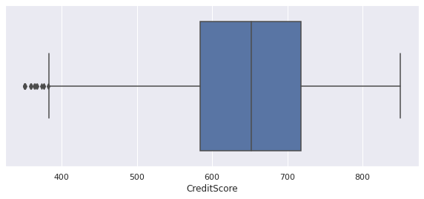

# 7.Check for Categorical columns and perform encoding.

In [12]:

df**=**pd**.**read_csv("Churn_Modelling.csv")

df**.**columns

**import** pandas **as** pd

**import** numpy **as** np

headers**=**['RowNumber','CustomerID','Surname','CreditScore','Geography',

'Gender','Age','Tenure','Balance','NumofProducts','HasCard'

'IsActiveMember','EstimatedSalary','Exited']

**import** seaborn **as** sns

df**.**head()

Out[12]:

|  | **RowNumber** | **CustomerId** | **Surname** | **CreditScore** | **Geography** | **Gender** | **Age** | **Tenure** | **Balance** | **Nanoproducts** | **HasCrCard** | **IsActiveMember** | **EstimatedSalary** | **Exited** |
| --- | --- | --- | --- | --- | --- | --- | --- | --- | --- | --- | --- | --- | --- | --- |
| **0** | 1 | 15634602 | Hargrave | 619 | France | Female | 42 | 2 | 0.00 | 1 | 1 | 1 | 101348.88 | 1 |
| **1** | 2 | 15647311 | Hill | 608 | Spain | Female | 41 | 1 | 83807.86 | 1 | 0 | 1 | 112542.58 | 0 |
| **2** | 3 | 15619304 | Onio | 502 | France | Female | 42 | 8 | 159660.80 | 3 | 1 | 0 | 113931.57 | 1 |
| **3** | 4 | 15701354 | Boni | 699 | France | Female | 39 | 1 | 0.00 | 2 | 0 | 0 | 93826.63 | 0 |
| **4** | 5 | 15737888 | Mitchell | 850 | Spain | Female | 43 | 2 | 125510.82 | 1 | 1 | 1 | 79084.10 | 0 |

# 8.Split the data into dependent and independent variables.

In [34]:

*#Splitting the Dataset into the Independent Feature Matrix:*

X **=** df**.**iloc[:, :**-**1]**.**values

print(X)

[[1 15634602 'Hargrave' ... 1 1 101348.88]

[2 15647311 'Hill' ... 0 1 112542.58]

[3 15619304 'Onio' ... 1 0 113931.57]

...

[9998 15584532 'Liu' ... 0 1 42085.58]

[9999 15682355 'Sabbatini' ... 1 0 92888.52]

[10000 15628319 'Walker' ... 1 0 38190.78]]

In [36]:

*#Extracting the Dataset to Get the Dependent Vector*

Y **=** df**.**iloc[:, **-**1]**.**values

print(Y)

[1 0 1 ... 1 1 0]

# 9.Scale the independent variables

In [48]:

**from** sklearn.preprocessing **import** StandardScaler

In [53]:

object**=** StandardScaler()

*# standardization*

scale**=**object**.**fit_transform(x)

print(scale)

[[-0.78321342]

[-0.60653412]

[-0.99588476]

...

[-1.47928179]

[-0.11935577]

[-0.87055909]]

# 10.Split the data into training and testing

In [40]:

**from** sklearn.model_selection **import** train_test_split

*# split the dataset*

X_train, X_test, Y_train, Y_test **=** train_test_split(X, Y, test_size**=**0.05, random_state**=**0)

In [41]:

X_train

Out[41]:

array([[800, 15567367, 'Tao', ..., 0, 1, 103315.74],

[1070, 15628674, 'Iadanza', ..., 1, 0, 31904.31],

[8411, 15609913, 'Clark', ..., 1, 0, 113436.08],

...,

[3265, 15574372, 'Hoolan', ..., 1, 0, 181429.87],

[9846, 15664035, 'Parsons', ..., 1, 1, 148750.16],

[2733, 15592816, 'Udokamma', ..., 1, 0, 118855.26]], dtype=object)

In [42]:

Y_train

Out[42]:

array([0, 1, 0, ..., 0, 0, 1])

In [43]:

X_test

Out[43]:

array([[9395, 15615753, 'Upchurch', ..., 1, 1, 192852.67],

[899, 15654700, 'Fallaci', ..., 1, 0, 128702.1],

[2399, 15633877, 'Morrison', ..., 1, 1, 75732.25],

...,

[492, 15699005, 'Martin', ..., 1, 1, 9983.88],

[2022, 15795519, 'Vasiliev', ..., 0, 0, 197322.13],

[4300, 15711991, 'Chiawuotu', ..., 0, 0, 3183.15]], dtype=object)

In [44]:

Y_test

Out[44]:

array([0, 1, 0, 0, 0, 1, 0, 0, 1, 1, 0, 0, 0, 0, 1, 1, 0, 0, 0, 0, 0, 0,

0, 0, 0, 0, 0, 0, 0, 0, 0, 1, 0, 0, 0, 0, 0, 0, 0, 0, 0, 1, 1, 0,

0, 0, 0, 0, 0, 0, 1, 0, 0, 0, 0, 0, 0, 0, 1, 1, 0, 0, 0, 1, 1, 1,

0, 0, 0, 1, 0, 0, 0, 1, 1, 0, 1, 0, 0, 0, 1, 1, 0, 0, 1, 0, 0, 0,

1, 0, 0, 0, 0, 1, 0, 1, 0, 0, 0, 0, 0, 0, 0, 0, 0, 0, 0, 1, 0, 0,

0, 1, 1, 0, 1, 0, 0, 0, 0, 0, 1, 0, 1, 0, 0, 1, 0, 0, 0, 1, 0, 0,

0, 0, 0, 0, 0, 1, 0, 0, 0, 0, 1, 0, 0, 1, 0, 1, 0, 1, 0, 0, 0, 0,

1, 1, 1, 0, 0, 0, 0, 0, 0, 0, 0, 0, 0, 0, 0, 0, 0, 0, 0, 1, 1, 0,

0, 0, 0, 0, 0, 0, 1, 1, 0, 1, 0, 0, 0, 0, 1, 0, 0, 0, 0, 0, 0, 1,

0, 0, 0, 0, 0, 0, 0, 0, 0, 0, 0, 0, 0, 0, 1, 1, 0, 0, 0, 0, 0, 1,

0, 0, 0, 0, 0, 0, 0, 0, 0, 0, 1, 0, 0, 0, 0, 0, 0, 0, 0, 0, 0, 0,

0, 1, 0, 0, 0, 1, 0, 0, 0, 1, 0, 1, 0, 0, 0, 0, 0, 0, 0, 0, 0, 0,

0, 0, 0, 1, 0, 0, 0, 0, 0, 1, 1, 1, 0, 0, 0, 0, 0, 0, 0, 0, 0, 0,

0, 1, 0, 1, 0, 0, 0, 0, 0, 0, 0, 0, 0, 1, 0, 0, 0, 0, 0, 0, 0, 0,

1, 0, 0, 0, 1, 0, 0, 0, 0, 1, 1, 0, 1, 0, 0, 1, 0, 0, 0, 0, 0, 0,

0, 0, 0, 0, 0, 0, 0, 0, 0, 0, 0, 1, 0, 1, 0, 1, 0, 1, 0, 0, 0, 0,

0, 1, 0, 1, 1, 0, 0, 0, 0, 0, 0, 1, 1, 1, 0, 1, 0, 0, 0, 0, 0, 0,

0, 0, 0, 1, 0, 0, 0, 0, 0, 0, 0, 0, 1, 0, 1, 1, 0, 0, 0, 0, 0, 0,

0, 0, 0, 0, 0, 1, 0, 0, 0, 1, 0, 0, 0, 0, 0, 0, 0, 0, 0, 0, 1, 0,

0, 0, 0, 1, 0, 0, 0, 0, 0, 0, 0, 0, 0, 0, 1, 0, 1, 0, 0, 0, 0, 0,

0, 0, 0, 0, 0, 0, 0, 0, 0, 0, 0, 0, 1, 0, 0, 0, 0, 0, 0, 0, 0, 0,

0, 0, 0, 1, 0, 1, 0, 0, 0, 0, 0, 1, 0, 0, 0, 0, 0, 1, 0, 0, 0, 0,

0, 1, 0, 0, 1, 0, 1, 1, 0, 0, 0, 0, 0, 0, 0, 0])